Independent Book Project:
Bring Your Book to Life
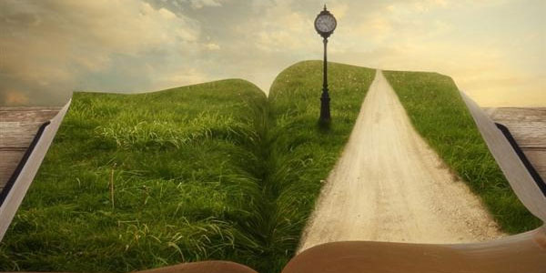

*You will choose one of the following projects to complete.
Diorama: Create a 3D display of a particularly interesting scene/moment/event in your book. The display should be polished, neat, colorful, and carefully designed. Think about how you are going to construct the scenery, choosing materials that will best highlight your chosen event. Be sure to include details and characters that are important to this event. Then, please just write one paragraph, explaining your details and why this scene was so important in your book.

Movie Trailer: Put together a movie trailer for your book, as if your book is going to be released in movie theaters soon. Before choosing this project, make sure you have the correct software and technology, including a way to save your movie trailer so that I can view it as well. Think about the music you will have playing in the background, any special effects/transitions, and the text you will have flashing on the screen. Consider who you will incorporate into your movie trailer to make it feel authentic. (Your trailer should be at least two minutes long but no longer than four minutes.)

T-Shirt: Design a real t-shirt that properly captures the theme (message) of your book. You can include a favorite quote (a line or two) from the book, a sketch of one of the characters, an illustration of one of the most important scenes, adjectives to describe this book, etc. Then, please just write one paragraph, explaining why you designed your t-shirt the way you did. The more detail and color included in this shirt, the better it will look. (You can even wear your own creation to school!)

Children’s Picture Book or Pop-Up Book: Create an illustrated picture book version or pop-up version of your book. It must be neat, colorful, and written for children. Imagine taking the book you read and then redesigning it so that a 6-year-old would be interested in your book and could easily understand the plot, characters, setting, theme, etc. A picture book should include bits of text on each page, along with illustrations. Plan on creating between 10-15 pages for your picture book. If your book goes over 15 pages, that’s fine. However, anything under 10 pages will not meet the length requirement. You’ll create a snazzy cover too! (I may ask if I can borrow this for a day to read to the elementary kids!)

Graphic Novel: Using your love and knowledge for how graphic novels are designed, you are going to create your own graphic novel for your book! If you choose to complete this project, you will design a new cover for the outside of your graphic novel, and you will include 14-20 pages to properly demonstrate the most important scenes/moments of your book. By reading your graphic novel, I should feel like I understand the general plot of your book.

Radio Interview or Talk Show: Write and record a mock “radio interview” or talk show that would make people want to read your book. If you are good at doing different voices, then you are welcome to be both the interviewer and the interviewee. If you want to get other people involved (so that you don’t have to do both roles), that’s fine too. Your interview or show should be between four and seven minutes long. Be clear, loud, and engaging when you are speaking.

Board Game: Design a board game designed around the events and themes of your book. The game pieces, cards, rules, and set up of the board is up to you, but your choices should be appropriate for the plot of your book. Then a group of us can play your game one day during lunch (if you so choose)!

CD: Create a CD for your book, including at least 12 appropriate songs (that you already have access to). You will use a plastic CD case and design a cover for the outside of your case. Inside, you will burn a CD with the 12 songs you chose (and you will then get to keep this CD for your own personal use). Just like with a real CD, you will include a song booklet on the inside; this song booklet will list the songs (in order) and a brief explanation of how each song depicts a certain scene/moment from your book.

